Assignment on

Internet Technologies

Assignment Weightage & Type

60% Portfolio Coursework

Corse: BSc (Hons) CS & DF

Sem_2

UWE ID: 24030171

Student Name: MD Faisal

Assignment Date: Week_2

TCP/IP

TCP/IP

TCP/IP (Transmission Control Protocol/Internet Protocol) is a suite of communication protocols used to interconnect devices on the internet and other computer networks. It is a fundamental technology that enables communication between devices and applications over the internet.

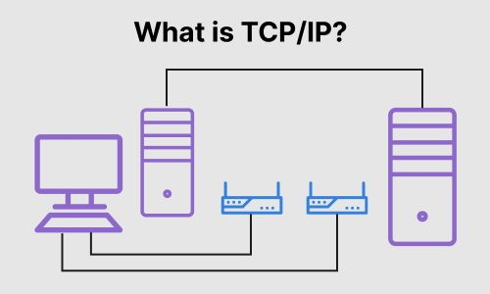

Layers of TCP/IP Reference Model

The TCP/IP Reference Model is a four-layered suite of communication protocols. It was developed by the Department of Defence(DoD) in the 1960s. The four layers of the TCP/IP Reference Model are:

* + Host-to-Network Layer: This is the lowest layer that is concerned with the physical transmission of data. TCP/IP does not specifically define any protocol here, but supports all the standard protocols.
  + Internet Layer: This layer defines the protocols for logical transmission of data over the network. The main protocol in this layer is Internet Protocol (IP) and it is supported by the protocols ICMP, IGMP, RARP, and ARP.
  + Transport Layer: This layer is responsible for error-free end-to-end delivery of data. The protocols defined here are Transmission Control Protocol (TCP) and User Datagram Protocol (UDP).
  + Application Layer: This is the topmost layer and defines the interface of host programs with the transport layer services. This layer includes all high-level protocols like Telnet, DNS, HTTP, FTP, SMTP, etc.

ISO-OSI Seven Layer Model Recalled

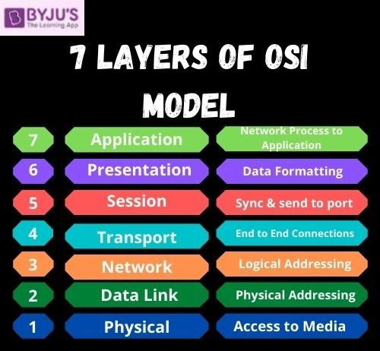

Comparison of ISO-OSI Model and TCP/IP Model

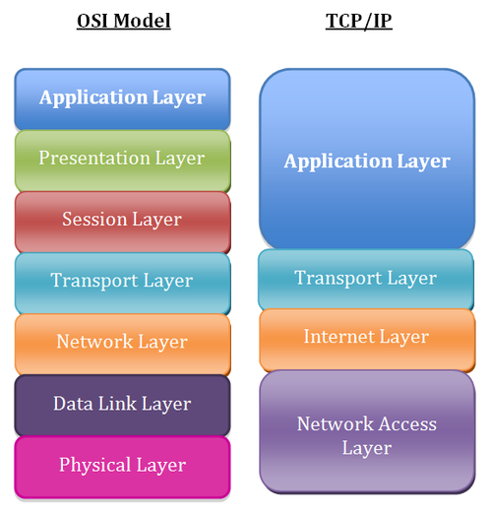

Layer Reference to Protocol

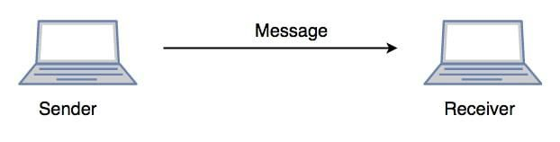

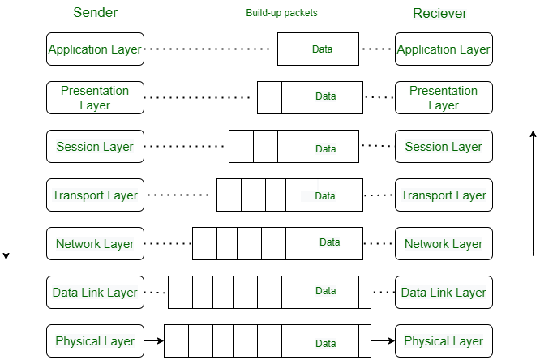

TCP/IP Layers

1. Network Access Layer
2. Internet Layer
3. Transport Layer
4. Application Layer

1. Network Access Layer (Layer 1)

* Also known as the link layer, this layer is responsible for transmitting data between devices on the same network.
* It defines the protocols for data transmission, such as Ethernet or Wi-Fi.
* Protocols: ARP (Address Resolution Protocol), RARP (Reverse Address Resolution Protocol), ICMP (Internet Control Message Protocol)

2. Internet Layer (Layer 2)

* Also known as the network layer, this layer is responsible for routing data between networks.
* It defines the protocols for addressing and routing data, such as IP (Internet Protocol).
* Protocols: IP (Internet Protocol), ICMP (Internet Control Message Protocol)

3. Transport Layer (Layer 3)

* This layer is responsible for ensuring reliable data transfer between devices.
* It defines the protocols for establishing, maintaining, and terminating connections, such as TCP (Transmission Control Protocol) and UDP (User Datagram Protocol).
* Protocols: TCP (Transmission Control Protocol), UDP (User Datagram Protocol), SCTP (Stream Control Transmission Protocol)

4. Application Layer (Layer 4)

* This layer is responsible for providing services to end-user applications, such as email, file transfer, and web browsing.
* It defines the protocols for communication between applications, such as HTTP (Hypertext Transfer Protocol), FTP (File Transfer Protocol), and SMTP (Simple Mail Transfer Protocol).
* Protocols: HTTP (Hypertext Transfer Protocol), FTP (File Transfer Protocol), SMTP (Simple Mail Transfer Protocol), DNS (Domain Name System)

Relationship to OSI model

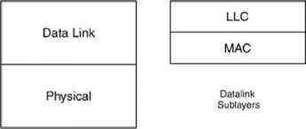

Core Internet Layer Protocols

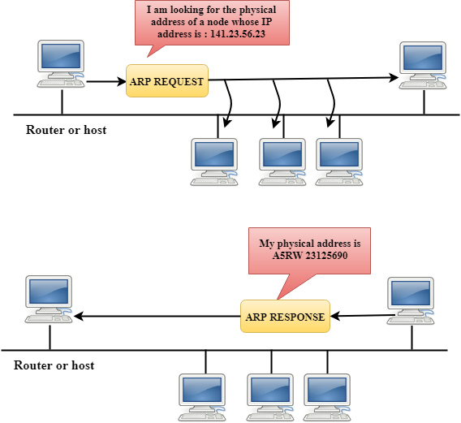

Core Protocols of the Transport Layer

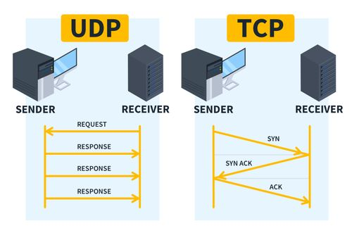

TCP

* Transmission Control Protocol (TCP)
* One-to-one and connection-oriented reliable protocol
* Used in the accurate transmission of large amount of data
* Slower compared to UDP because of additional error checking being performed

UDP

* User Datagram Protocol (UDP)
* One-to-one or one-to-many,connectionless and unreliable protocol

Some Core Protocols

* HTTP
* FTP
* Telnet
* SMTP
* POP3
* IMAP
* SNMP(Simple Network Management Protocol) etc.

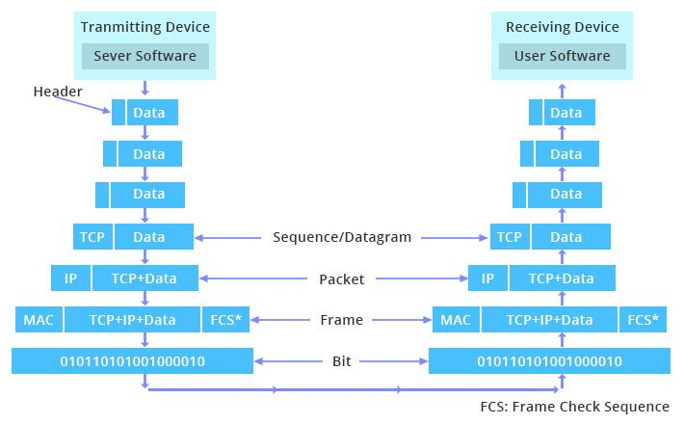

What is Search Engine?

A search engine is a software program that helps people find the information they are looking for online using keywords or phrases. It is a computer system designed to perform searches of files stored in a database through spiders or bots. When the search engine receives a query or makes a query in the database, it offers the result on a results page.

How to access a search engine

You can also access search engines through their mobile apps or voice assistants like Siri, Google Assistant, or Alexa.

How a search engine works

A search engine is an online tool that searches for results in its database based on the search query (keyword) submitted by the internet user. The process of how a search engine works involves several stages:

Crawling: Search engines use software known as web crawlers, bots, or spiders to explore the web regularly to find pages to add to their index. These web crawlers navigate the web by downloading web pages and following links on these pages to discover new pages that have been made available.

Indexing: Once the bots crawl the data, it’s time for indexing – the process of validating and storing the content from the webpages in the search engine’s database called the index. This index is a big library of all the websites. Your website has to be indexed in order to be displayed on the search engine results page.

Query Processing: When a user enters a query into a search engine, the search engine’s algorithm analyzes the query to understand what the user is looking for. The algorithm then searches the index for relevant results and ranks them based on their relevance, authority, and other factors.

Ranking: The search engine’s algorithm ranks the found pages in order of their relevance. The ranking is done based on a number of factors, including keyword density, speed, and links. The search engine’s aim is to provide the user with the most relevant result.

Returning Results: The search engine returns the ranked results to the user in the form of a search engine results page (SERP). The SERP may include various types of content, such as text pages, images, videos, maps, articles, and shopping pages.

Continuous Crawling and Indexing: Crawling and indexing are continuous processes that take place over and over again to keep the database fresh. This ensures that the search engine’s index remains up-to-date and accurate.

Structured Data: Some search engines use structured data on websites to help them understand and display specific types of content. This is a code added to the HTML markup. Using structured data means that information such as review ratings, images, addresses, and phone numbers can appear on the search engine results page.

Universal or Blended Search: Some search engines present different content types in the search results to users. As well as traditional text page results, the SERP may also show rich media content, such as images, videos, maps, articles, and shopping pages.

Understanding How Search Engines Work: Understanding how search engines work can help your business use SEO (Search Engine Optimization) to reach potential customers. By following SEO best practices, you can ensure that your website is indexed correctly and appears in search results for relevant queries.

What is search engine crawling?

Search engine crawling is the process used by search engines and web crawlers (bots or spiders) to visit and download a webpage and extract its links to discover additional pages. This process is crucial for search engines to understand the web and provide relevant search results.

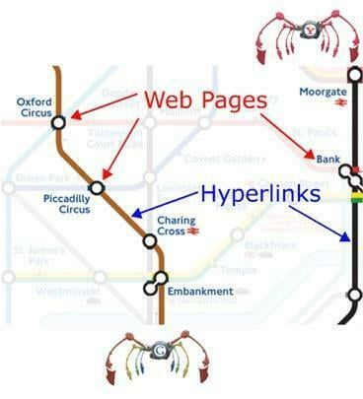

What is a search engine index?

A search engine index is a massive database that stores information about the web pages and content it has crawled and processed. It’s a crucial component of a search engine’s functionality, enabling fast and accurate information retrieval. The index is built by collecting, parsing, and storing data from the web, which is then used to generate search results when a user submits a query.

Search engine ranking

Search engine ranking refers to the position a URL takes on the results page of a search engine. It is a crucial aspect of online marketing, as it determines how visible a website is to users searching for specific keywords or phrases. A search engine ranking refers to the spot a URL takes on the results page of a search engine. A wide variety of factors determine a website’s ranking, including:

The most popular search engines

* Google
* Baidu
* Bing
* Yahoo!
* Yandex
* Ask
* DuckDuckGo

What is Web Hosting?

Web hosting is a service that allows organizations and individuals to post a website or web page onto the Internet. A web host, or web hosting service provider, is a business that provides the technologies and services needed for the website or webpage to be viewed in the Internet.

Web hosting is a service mainly for the purpose of:

* Storing and maintaining website files and applications on a server to make them accessible on the internet.
* Providing a space on the internet for organizations and individuals to publish their website or web page.
* Enabling companies to subcontract one or more web-based core functions to a hosting provider.
* Renting a space on the internet for a website or web page, similar to renting a physical space for a physical store.
* Storing and maintaining website files and applications on a server to make its customers’ websites accessible on the internet.
* Providing a way for people to access website files through a web browser.



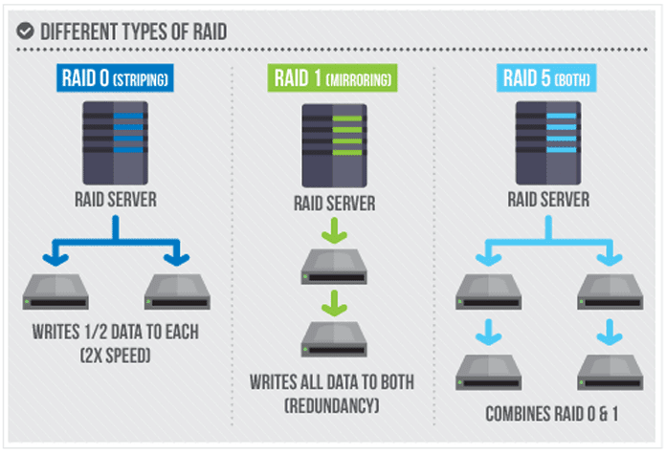

Are domain name and Web Hosting the Same?

Domain Name:

* Unique identifier for your website
* Helps users find and access your website
* Not a physical location, but a virtual address
* Can be registered and managed separately from web hosting

Web Hosting:

* Service that stores and serves your website’s files
* Provides storage space, bandwidth, and other resources
* Can be thought of as a physical location where your website is stored
* Often purchased together with a domain name, but can be separate services

In summary, a domain name is the address of your website, while web hosting is the service that stores and serves your website’s files. While they are related, they are not the same thing.



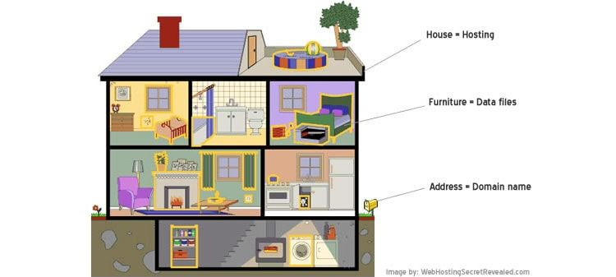

Domain name registration

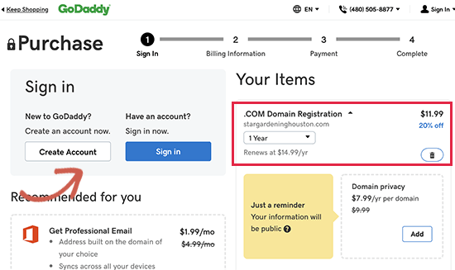

DNS – Domain Name System

The Domain Name System (DNS) is a hierarchical naming system built on a distributed database for computers, services, or any resource connected to the Internet or a private network. It translates human-readable domain names into the numerical identifiers associated with networking equipment, enabling devices to be located and connected worldwide. Analogous to a network “phone book,” DNS is how a browser can translate a domain name (e.g., “facebook.com”) to the actual IP address of the server, which stores the information requested by the browser.

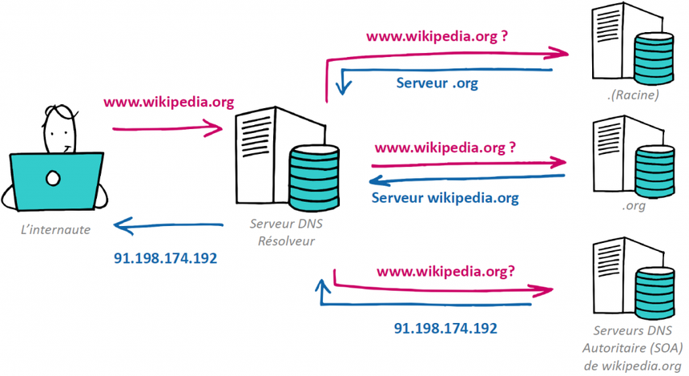

How DNS Work

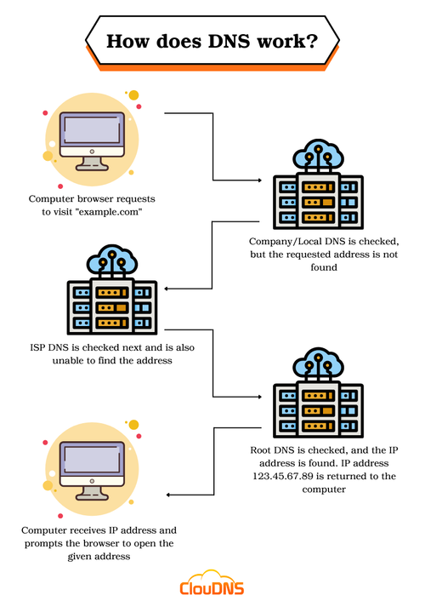

Web hosting

Web hosting is a service that allows you to store your website’s files on a remote server, making them accessible to the public on the internet. It’s the foundation of your online presence, and choosing the right web hosting service can be crucial for your website’s success.

Site Control

Site control refers to the management and coordination of a construction site, ensuring that all activities are carried out safely, efficiently, and according to plan. It involves setting up a system to control the site, including establishing control points, monitoring progress, and making adjustments as needed.

Web Host Manager(WHM)

Web Host Manager (WHM) is a powerful program that allows administrative access to the back end of cPanel. It provides a graphical interface for managing multiple cPanel accounts, making it an essential tool for hosting providers, resellers, and system administrators.

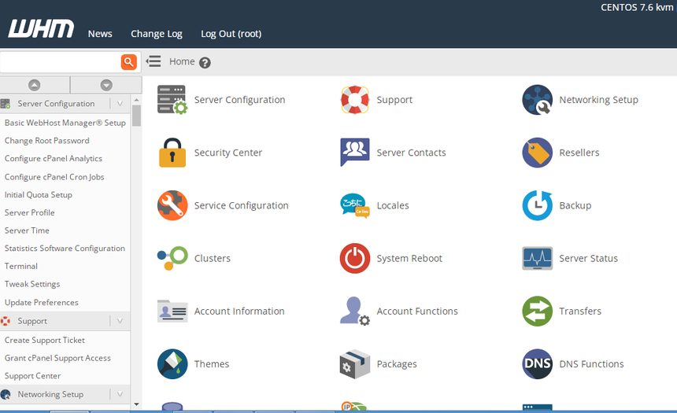

cPanel

cPanel is a web-based control panel used to manage and control web hosting services. It provides a user-friendly interface for website owners and developers to manage their hosting accounts, files, databases, email accounts, and other aspects of their website. Here are some of the key uses of cPanel:

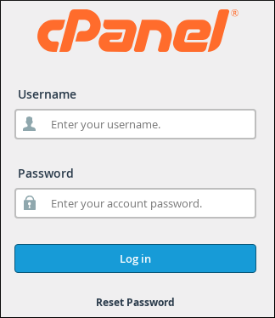

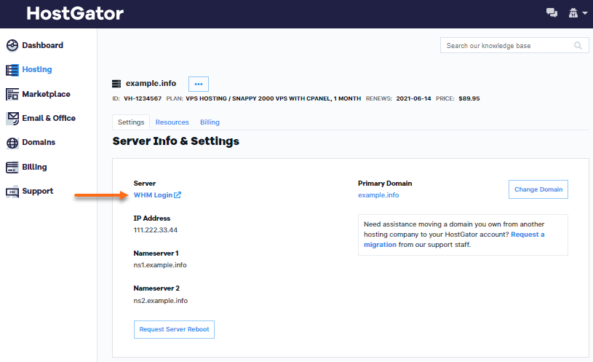

Uses of Cpanel

Cpanel is a web-based control panel that provides a graphical interface for managing various aspects of a website or hosting account. Here are some of the uses of Cpanel:

* + File Management: Cpanel allows users to manage their files, including uploading, downloading, and deleting files, as well as creating and managing directories.
  + Database Management: Cpanel provides tools for managing databases, including creating and managing MySQL databases, as well as importing and exporting database data.
    - Email Management: Cpanel allows users to manage their email accounts, including creating and managing email accounts, setting up email forwarding, and configuring email filters.
    - Domain Management: Cpanel provides tools for managing domains, including creating and managing subdomains, setting up DNS records, and configuring domain parking.
  + Security: Cpanel provides security features, such as SSL certificates, password protection, and IP blocking, to help protect websites and hosting accounts from unauthorized access.
    - Backup and Restore: Cpanel allows users to create backups of their files and databases, and restore them in case of data loss or corruption.
  + Software Installation: Cpanel provides a Softaculous installer that allows users to easily install popular software applications, such as WordPress, Joomla, and Drupal.
  + Monitoring and Analytics: Cpanel provides tools for monitoring website traffic, bandwidth usage, and other metrics, as well as analytics tools to help users understand their website’s performance.
    - Reseller Management: Cpanel provides features for resellers to manage their customers’ accounts, including creating and managing sub-accounts, setting up reseller packages, and monitoring customer activity.
* Server Management: Cpanel provides tools for server administrators to manage the server, including configuring server settings, managing user accounts, and monitoring server performance.

